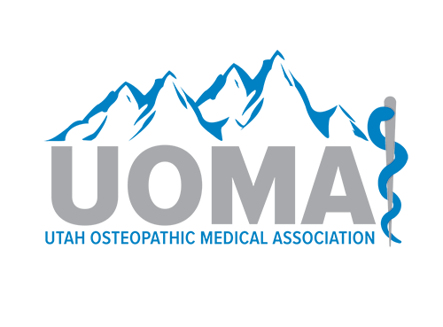 Utah Osteopathic Medical Association &

[*Your organization’s name and logo]*

Certificate of Award

Certifies that

**[Name of Learner], MD**

has participated in the [*Title of the CME Activity*] at

[Location of Activity] on [Date of Activity],

and is awarded [# of credits awarded] *AMA PRA Category 1 Credit*™*.*

This activity has been planned and implemented in accordance with the accreditation requirements and policies of the Accreditation Council for Continuing Medical Education (ACCME) through the joint sponsorship of the American Osteopathic Association (AOA) and the Utah Osteopathic Medical Association (UOMA). The AOA is accredited by the ACCME to provide continuing medical education for physicians. AOA designates this live activity for a maximum of 20.25 *AMA PRA Category 1 Credit*™.  Physicians should claim only the credit commensurate with the extent of their participation in the activity.